Crop Ecology. Exercises with results from LINTUL1. Tuesday, 19 January 2010

Purpose: to get a feeling about the order of magnitude of potential crop production under different climatic conditions, and crop-model sensitivity for emergence date and some parameters.

Note: choose either wheat growth in Brazil or in the Netherlands. If you are fast enough you can also compare the results of the two locations.

For those who wish to calculate potential production for Brazil:

The effect of weather and different emerging dates on crop growth
Crop growth is strongly dependent on the weather. Variables that occur in the weather files are: day of the year; the irradiation (kJ m^{–2} d^{–1}); minimum temperature (˚C); maximum temperature (˚C); vapour pressure (kPa); mean wind speed (m s^{–1}); precipitation (mm d^{–1}).

We give results for the years 1971 (dry), 1974 (average year), or 1975 (wet). Furthermore, we have generated two data sets with LINTUL1 for each of these years:
Run 1: Emergence at 1 June (that is the default value: DOYEM=152.);
Run 2: Emergence at 1 July (DOYEM=182.);

Results are given for the yields, left figure, and for the LAI, right figure:
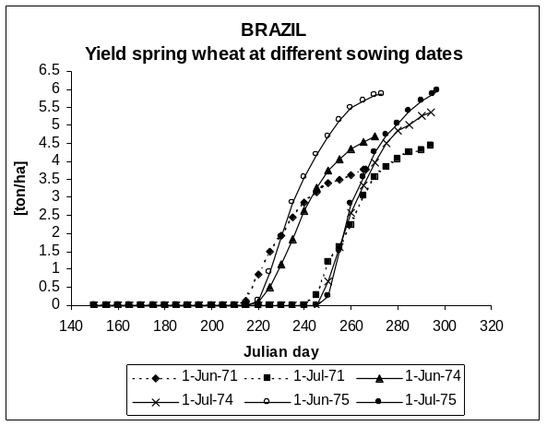
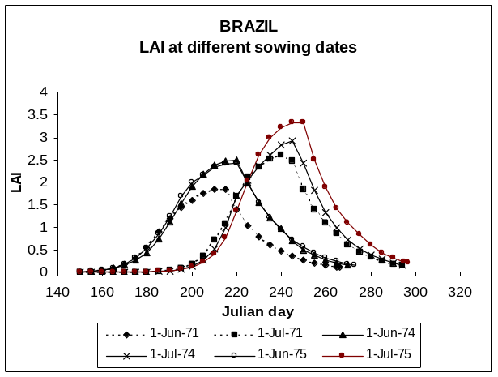

The numerical values of yield results and the difference between the yields for the different sowing dates are also given:

- 1971 (dry)
│difference emerg. June 1 (152) - emerg. July 1 (182)│ = 0.66 t/ha (= 66 g.m^{–2})
3.78 - 4.44
big difference in LAI development, see above figures of LAI versus time.

- 1974 (average)
│difference 4.70 - 5.35│ = 0.65 t/ha (= 65 g.m^{–2})
big difference in LAI, and also larger than dry year 1971

- 1975 (wet)
│difference 5.88 - 5.95│ = 0.07 t/ha (= 7 g.m^{–2})
big difference in LAI, and also little larger than 1974 (aver.)

Questions:
1) Which weather variables are important for calculating potential crop growth?

2) In which type of year is the yield highest.

3) Explain the possible causes why in that type of year the yield is highest, using the information of both figures.

4) Which sowing date would you recommend to a farmer if these figures were confirmed by experimental data?

The sensitivity of yield for some important crop parameters
The light extinction coefficient (K), the specific leaf area (SLA), the initial relative growth rate of the leaves (RGRL), the day of emergence (DOYEM), and the Light Use Efficiency (LUE) all affect crop yield. The Lintul-1 crop growth model was used to see which of these variables appear most important in determining yield. A model is said to be sensitive for a parameter if a slight change in that parameter causes an appreciable change in the model result. The results were all compared to the standard results, the so called default parameters.
We give the results for six model runs for each year (dry, average, wet), so in total 18 runs:
Run 0: Standard run with all parameters at the default value as indicated in the listing
Run 1: Increase K by 10%
Run 2: Increase SLA by 10%
Run 3: Increase RGRL by 10%
Run 4: Delay sowing, i.e. emergence day DOYEM, by 10 d.
Run 5: Increase LUE by 10%
The changes made in run 1-3 all increase cumulative light interception by the crop. The change in LUE, run 5, increases the efficiency by which the light is utilized to form dry matter in the crop.

In summary, the parameters are adapted as follows:
Default values Adapted values:
K = 0.6 Run 1 +10% = 0.66
SLA = 0.022 2 +10% = 0.0242
RGRL = 0.009 3 +10% = 0.0099
DOYEM 10 days later, so from 152 to → 4 +10 d = 162
LUE = 3.0 5 +10% = 3.3

Our results are given below:

- 1971 dry
∆K ∆SLA ∆RGRL ∆DOYEM ∆LUE

4.42 4.23 4.34 4.32 4.66
diff. 0.64 0.45 0.56 0.54 0.88
default yield (=Doyem 152) =3.78

- 1974 average
∆K ∆SLA ∆RGRL ∆DOYEM ∆LUE

5.42 5.25 5.25 5.98 5.77
diff. 0.72 0.55 0.55 1.28 1.07
default yield =4.70

- 1975 wet
∆K ∆SLA ∆RGRL ∆DOYEM ∆LUE

6.75 6.53 6.53 6.31 7.19
diff. 0.87 0.65 0.65 0.43 1.31
default yield =5.88

Questions:
5) What are the units of K, SLA, RGRL, DOYEM and LUE. Include in these units also the biological or physical entity. For example not only g, but g biomass, not g/g but, for instance, g water / g soil (soil moisture content on a weight basis).

6) Which parameter change increases final yield most? Distinguish between the parameters affecting the cumulative light interception of the crop (light capture) and the light utilization.
Explain the reasons for this.

The effect of sowing date on crop growth
The effect of sowing date on crop performance can easily be investigated by a model, rather then in experiments, although that might be a very interesting exercise, of course. To this purpose we made twelve runs and varied the day of emergence by setting DOYEM at 1 January, 1 February, 1 March … up to 1 December. Because no weather for 1976 is available, not all runs can be made for the wet year. They are therefore omitted here.
Our results are as follows:
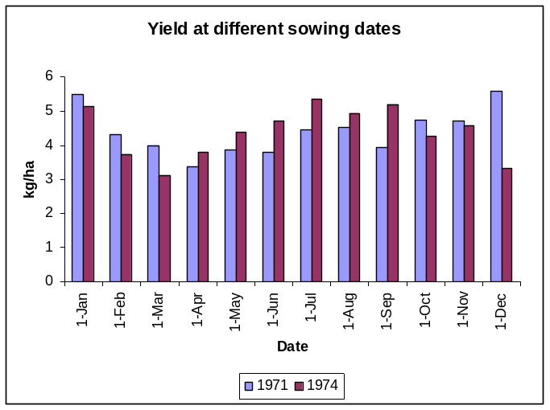
Questions:
7) Which month gives the highest potential yield?

8) Comment on the assumption that emergence and growth takes place throughout the whole of the year.

P.A. Leffelaar, Wageningen, 3 December 2009

Crop Ecology. Exercises with results from LINTUL1. Tuesday, 19 January 2010

Purpose: to get a feeling about the order of magnitude of potential crop production under different climatic conditions, and crop-model sensitivity for emergence date and some parameters.

Note: choose either wheat growth in Brazil or in the Netherlands. If you are fast enough you can also compare the results of the two locations.

For those who wish to calculate potential production for Netherlands:

The effect of weather and different emerging dates on crop growth
Crop growth is strongly dependent on the weather. Variables that occur in the weather files are: day of the year; the irradiation (kJ m^{–2} d^{–1}); minimum temperature (˚C); maximum temperature (˚C); vapour pressure (kPa); mean wind speed (m s^{–1}); precipitation (mm d^{–1}).

We give results for the years 1976 (dry), 1973 (average year), or 1970 (wet). Furthermore, we have generated two data sets with LINTUL1 for each of these years:
Run 1: Emergence at 1 March (that is the default value: DOYEM=60.);
Run 2: Emergence at 1 April (DOYEM=91.);

Results are given for the yields, left figure, and for the LAI, right figure:
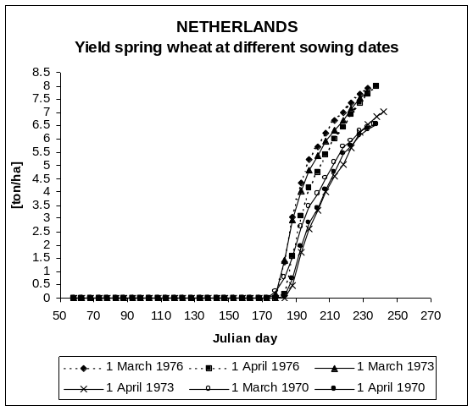
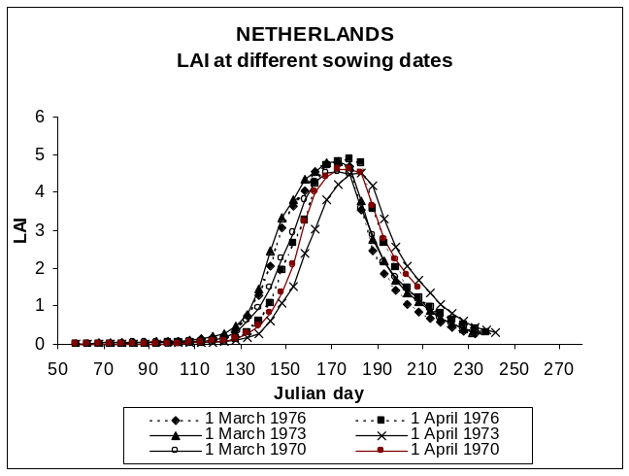

The numerical values of yield results and the difference between the yields for the different sowing dates are also given:

- 1970 (wet)
│difference emerg. March 1 (60) - emerg. April 1 (91) | = 0.20 t/ha
6.56 - 6.76
small difference in LAI's, see the above figures of LAI versus time.

- 1973 (average)
│difference 7.72 - 7.01│ = 0.71 t/ha
also little difference in LAI

- 1976 (dry)
│difference 7.92 - 7.99│ = 0.07 t/ha
figure LAI about similar to 1970

Questions:
1) Which weather variables are important for calculating potential crop growth?

2) In which type of year is the yield highest.

3) Explain the possible causes why in that type of year the yield is highest, using the information of both figures.

4) Which sowing date would you recommend to a farmer if these figures were confirmed by experimental data?

The sensitivity of yield for some important crop parameters
The light extinction coefficient (K), the specific leaf area (SLA), the initial relative growth rate of the leaves (RGRL), the day of emergence (DOYEM), and the Light Use Efficiency (LUE) all affect crop yield. The Lintul-1 crop growth model was used to see which of these variables appear most important in determining yield. A model is said to be sensitive for a parameter if a slight change in that parameter causes an appreciable change in the model result. The results were all compared to the standard results, the so called default parameters.
We give the results for six model runs for each year (dry, average, wet), so in total 18 runs:
Run 0: Standard run with all parameters at the default value as indicated in the listing
Run 1: Increase K by 10%
Run 2: Increase SLA by 10%
Run 3: Increase RGRL by 10%
Run 4: Delay sowing, i.e. emergence day DOYEM, by 10 d.
Run 5: Increase LUE by 10%
The changes made in run 1-3 all increase cumulative light interception by the crop. The change in LUE, run 5, increases the efficiency by which the light is utilized to form dry matter in the crop.

In summary, the parameters are adapted as follows:
Default values Adapted values:
K = 0.6 Run 1 +10% = 0.66
SLA = 0.022 2 +10% = 0.0242
RGRL = 0.009 3 +10% = 0.0099
DOYEM 10 days later, so from 152 to → 4 +10 d = 162
LUE = 3.0 5 +10% = 3.3

Our results are given below:

- 1970 wet
∆K ∆SLA ∆RGRL ∆DOYEM ∆LUE

7.05 6.82 6.76 6.50 7.50
diff. 0.49 0.26 0.20 -0.06 0.94
default yield (=Doyem 60)=6.56

∆K ∆SLA ∆RGRL ∆DOYEM ∆LUE

8.19 7.94 7.86 7.53 8.73
diff. 0.47 0.22 0.14 -0.19 1.01
- 1973 average
default yield =7.72

∆K ∆SLA ∆RGRL ∆DOYEM ∆LUE

8.47 8.19 8.10 7.95 9.01
diff. 0.55 0.27 0.18 0.03 1.09
- 1976 dry
default yield =7.92

Questions:
5) What are the units of K, SLA, RGRL, DOYEM and LUE. Include in these units also the biological or physical entity. For example not only g, but g biomass, not g/g but, for instance, g water / g soil (soil moisture content on a weight basis).

6) Which parameter change increases final yield most? Distinguish between the parameters affecting the cumulative light interception of the crop (light capture) and the light utilization.
Explain the reasons for this.

The effect of sowing date on crop growth
The effect of sowing date on crop performance can easily be investigated by a model, rather then in experiments, although that might be a very interesting exercise, of course. To this purpose we made twelve runs and varied the day of emergence by setting DOYEM at 1 January, 1 February, 1 March … up to 1 December. Because no weather for 1977 is available, not all runs can be made for the dry year. They are therefore omitted here.
Our results are as follows:

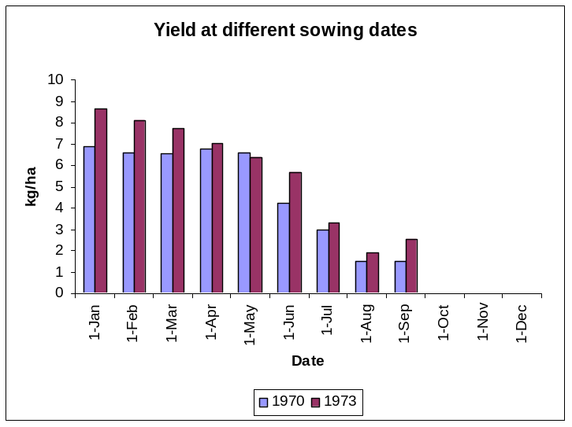
Questions:
7) Which month gives the highest potential yield?

8) Comment on the assumption that emergence and growth takes place throughout the whole of the year.

P.A. Leffelaar, Wageningen, 3 December 2009

